FOR IMMEDIATE RELEASE: February 14th, 2018

Contact: Clayton Dean Smith, Filmmaker
Phone: 917-304-1254
Email: captainbulldogproductions@gmail.com
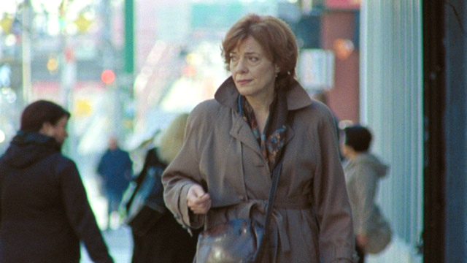

The award-winning short film Off Track Betty, shot on 16mm Kodak film at New York City locations that have since been demolished, will screen at the Queens World Film Festival on Friday, March 16th at 8:15pm.

Off Track Betty, an award-winning 19-minute film written and directed by Clayton Dean Smith, will screen at the Museum of the Moving Image as part of the 2018 Queens World Film Festival on Friday, March 16th at 8:15pm as part of the “Local Express” Shorts Block. Shot on 16mm Kodak film, it tells the story of a longtime resident of the Lower East Side who realizes she no longer recognizes her neighborhood. In a time of unprecedented development in New York and around the world, it is a story for anyone celebrating the places we call home, even as we rapidly move forward. A love letter to New York City, Off Track Betty asks: when is it right to hold on to what’s past, and when is it time to let go?

Off Track Betty won the Best Short Audience Award at the Brooklyn Film Festival, a Jury Award at Tallgrass Film Festival, and was an Official Selection at the Austin Film Festival, Bend Film Festival, Sidewalk Film Festival, Atlantic Film Festival, Napa Valley Film Festival, Phoenix Film Festival, Kansas City Film Festival and more.

The film was prominently featured in The New York Times due to the unique circumstances of production: nearly all the locations used in filming were slated for imminent demolition or gut renovation—which began 48 hours after the completion of filming. All of the film’s locations have since been emptied, altered beyond recognition, or demolished. The film has a considerable following on social media, was funded by a successful crowd-funding campaign, and had several features in the press during production.

Writer/Director Clayton Dean Smith is known as an actor of critical acclaim (The New York Times, The New Yorker, Time Out NY) in such projects as “Billions,” “Louie,” “30 Rock,” and “Flight of the Conchords,” and his stage appearances at companies including Clubbed Thumb, Atlantic Theater Company, Keen Company, Transport Group, and the Humana Festival. Off Track Betty is his directorial debut.

The film was shot by Cinematographer Giacomo Belletti (My First Kiss and the People Involved, L.A. Film Festival, Official Selection 2016; The Challenger, Best Feature Film, Palm Beach Int’l Film Festival 2015; Grand Prize, Rhode Island Int’l Film Festival 2015) and colored by Andrew Francis (Bleed for This, The Help, Carrie, Becoming Mike Nichols, Looper, The Avengers, Terence Malick’s The Tree of Life). Sound Designer Humberto Corte won the 2015 Leo Award for Sound Design for Grace: The Possession.

Leading actress Diane Ciesla appeared in the Sundance Special Jury Prize winner Another Earth in 2011. Since then credits include 5 Flights Up (with Morgan Freeman and Diane Keaton) and Fits And Starts (with Wyatt Cenac, directed by Laura Terruso), as well as the new TBS series “Search Party” (with Alia Shawkat).

Leading actor Corwin C. Tuggles made his television debut as Tyrone on the hit TV show “The Backyardigans.” On Broadway, he was in the original cast of Tony Kushner’s Caroline, or Change, and How The Grinch Stole Christmas. Other recent projects include “Broad City,” “Blue Bloods,” Detachment, and Ice Age: Continental Drift.

Actress Brooke Sunny Moriber received special mention by The New York Times for her role opposite Lili Taylor and Kristen Johnston in Aunt Dan and Lemon (dir. Scott Elliott). Other Broadway credits include Les Miserables, The Wild Party, Follies, Parade, The Threepenny Opera, James Joyce’s The Dead, and Aspects of Love. Brooke is also an acclaimed solo artist and regularly performs throughout New York City.

View the trailer for Off Track Betty at http://www.offtrackbettythemovie.com/. The official movie poster, film stills and production photos are available at http://www.offtrackbettythemovie.com/stills/.

Off Track Betty is a sponsored project of Independent Filmmaker Project (IFP).

